***KARAN*** K

16/10/2023

EC2 SERVER LAUNCH IN WINDSOWS :

1. ***Login to the aws free tier console then select the required service,I want EC2 service so I select EC2***
2. ***Screenshot1***

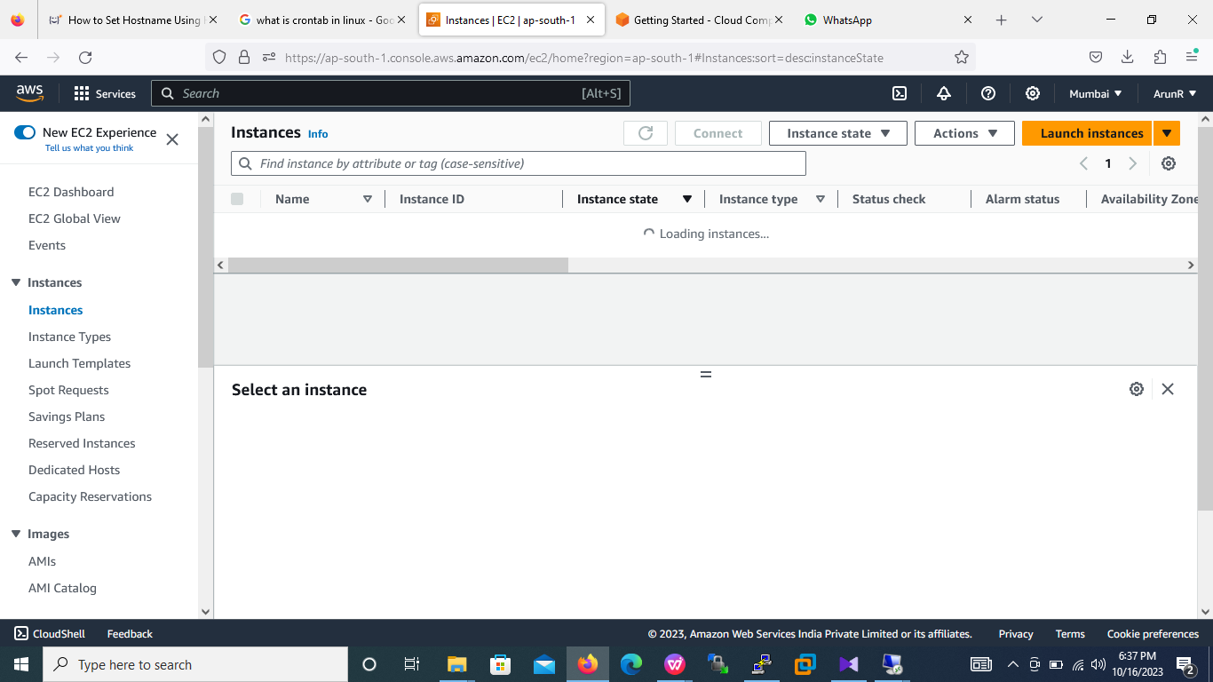

1. ***Next step is to launch instance by clicking Launch Instances button***
2. ***Screenshot2***



1. Enter the web server name

* Enter the name for in name and tags

Screenshot3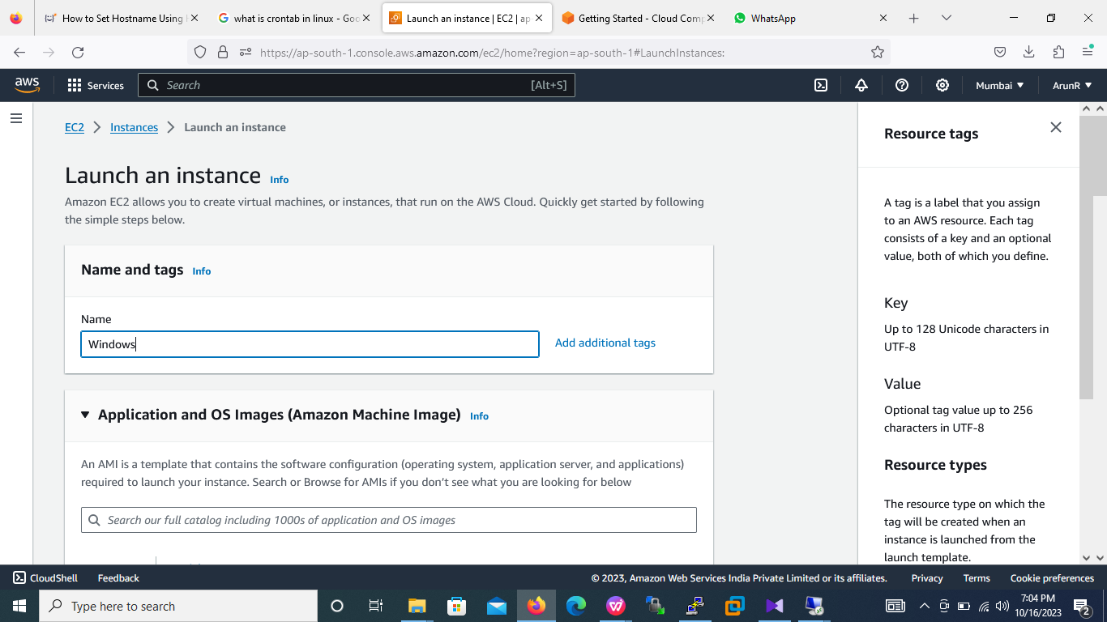

* To select required operating system

Screenshot4

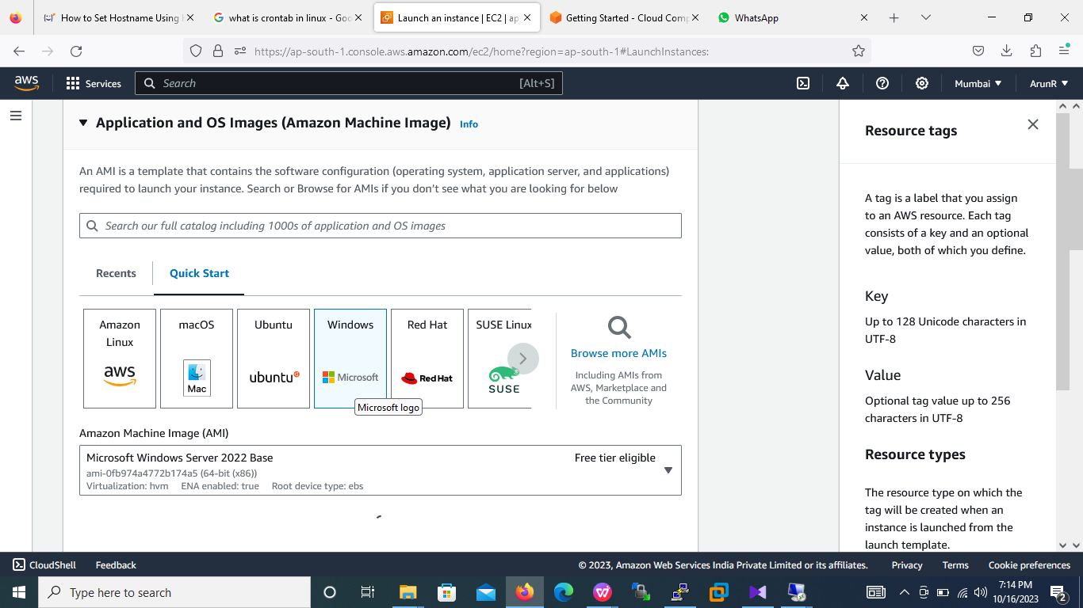

* Create a new key pair by proving a name and select the private key file format .pem (Refer the screenshot5)

Screesnhot5

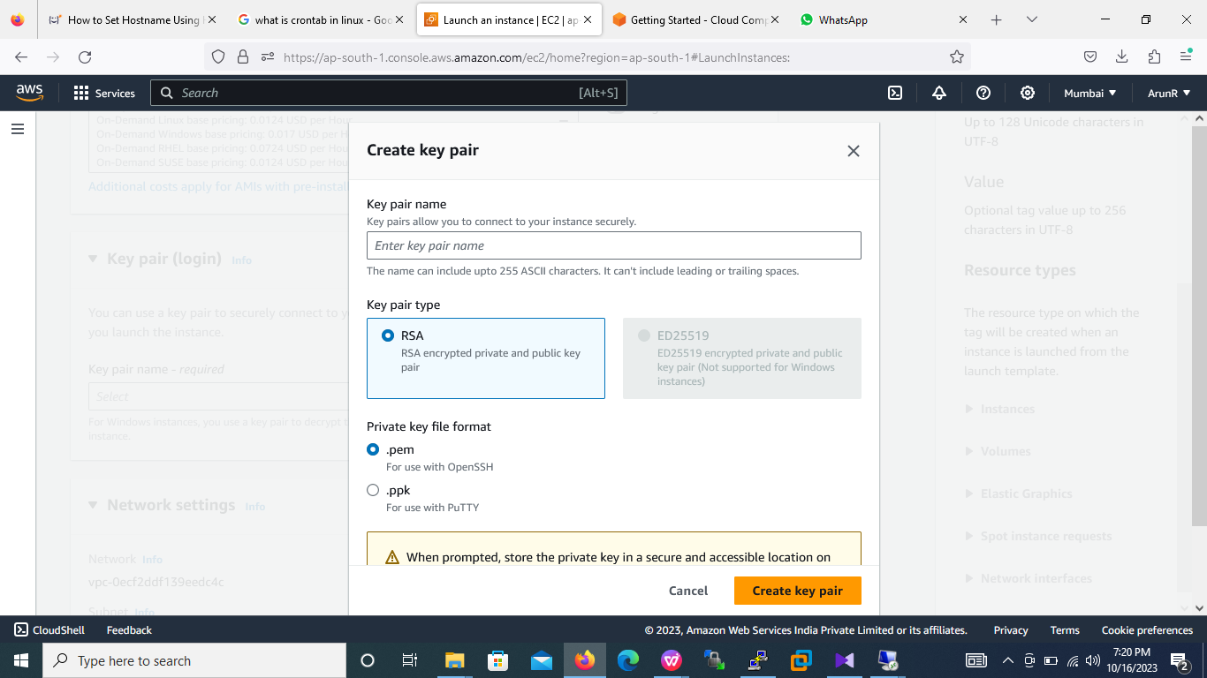

* Create security group for firewall and check / allow RDP traffic under network settings (Refer screesnhot6)

Screenshot6

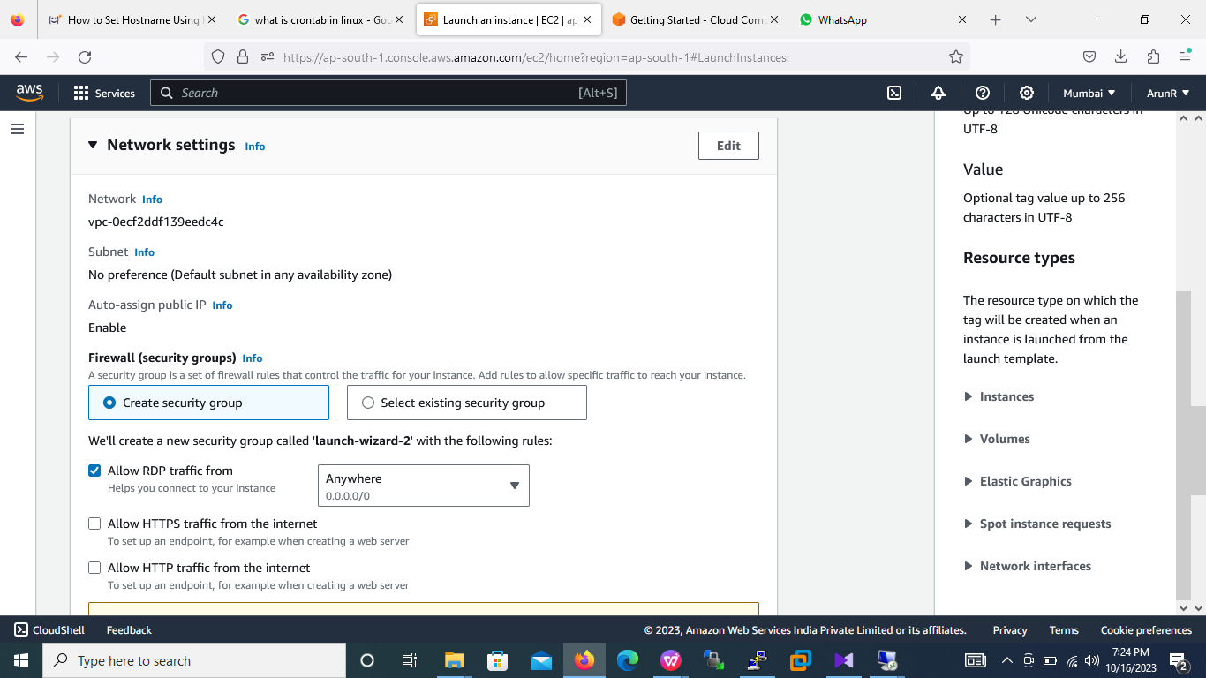

* Finally click on launch instance (Refer screesnhot7)

Scrteenshot7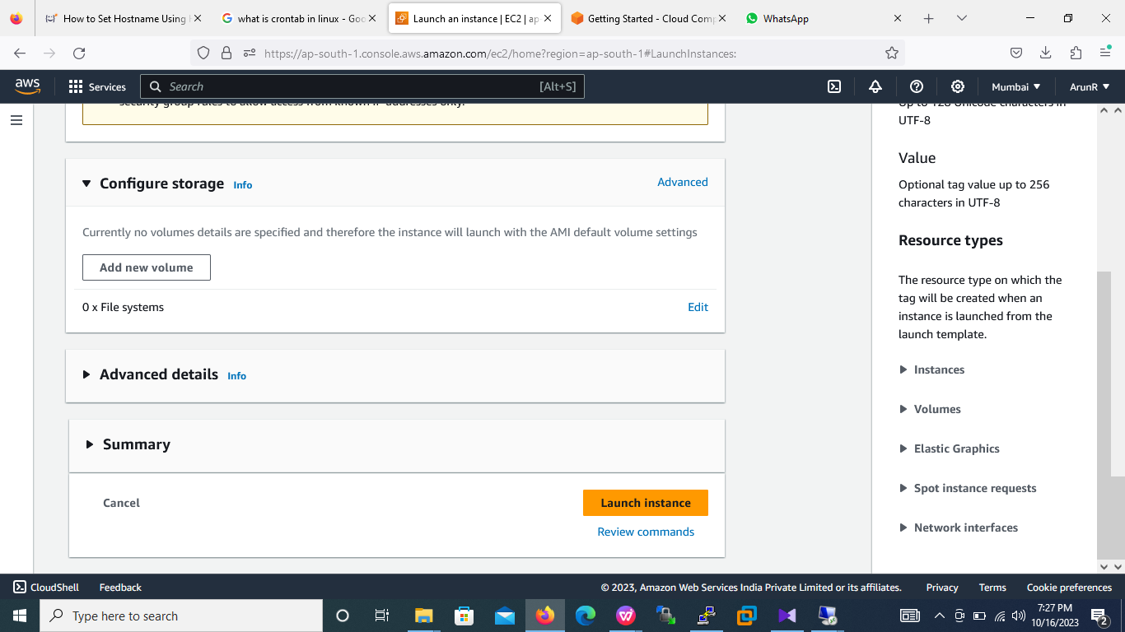

1. Once the instance successfully launch we can view all instances (Refer the screesnhot8),instances stats will be in running state and do a status 2/2 check pass.

Screesnhot8

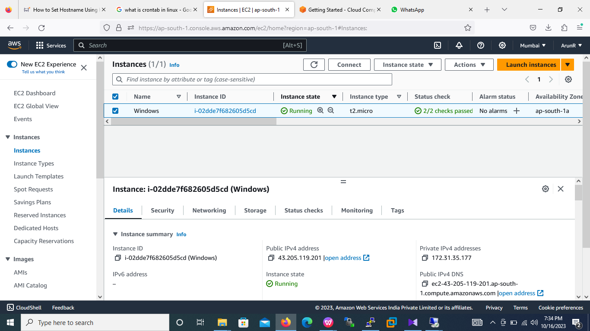

1. Next step is to connect the server using RDC by entering instance IPv4 address (Referscreesnhot9)

Screenshot9

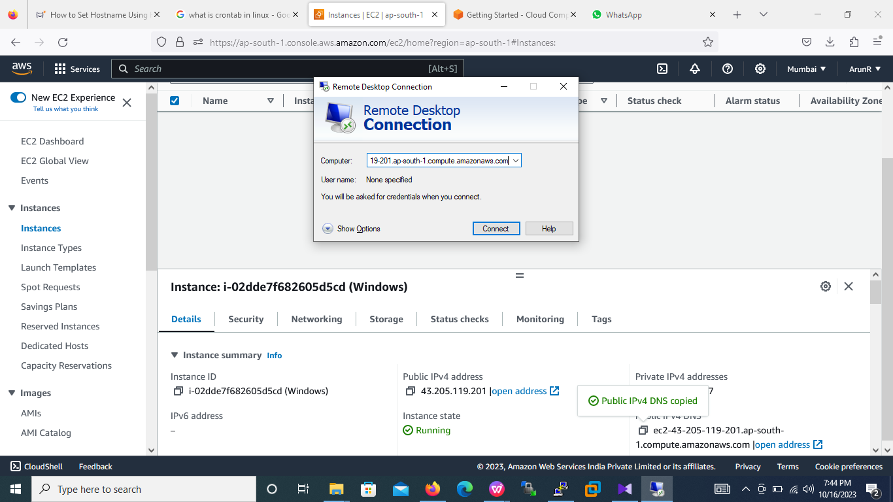

1. Connect to instance using RDPclient (Refer screesnhot10)

Scrernshot10

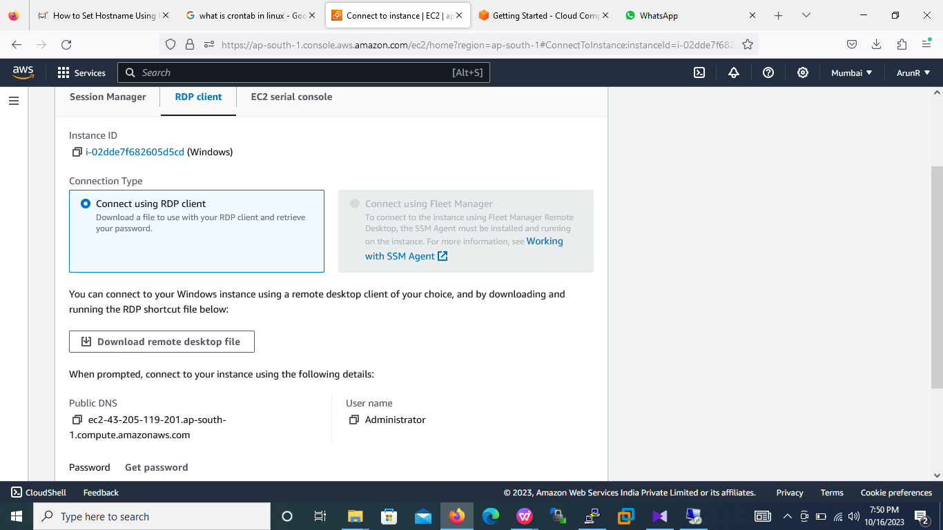

1. Decrypt the password using private key (Refer screeshot11)

Screesnhot11

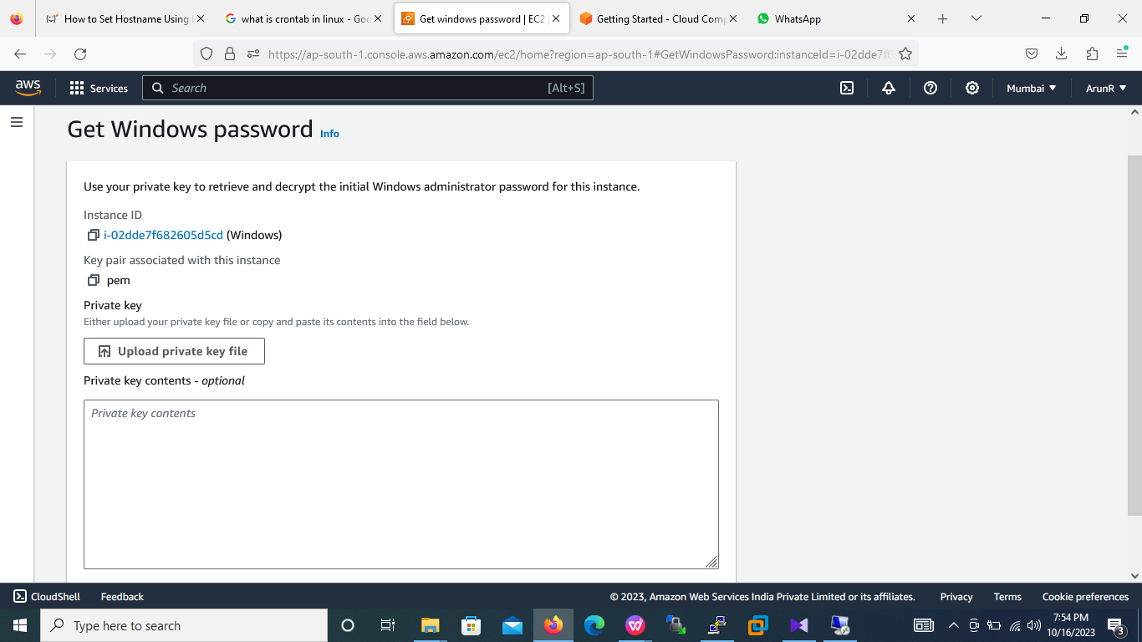

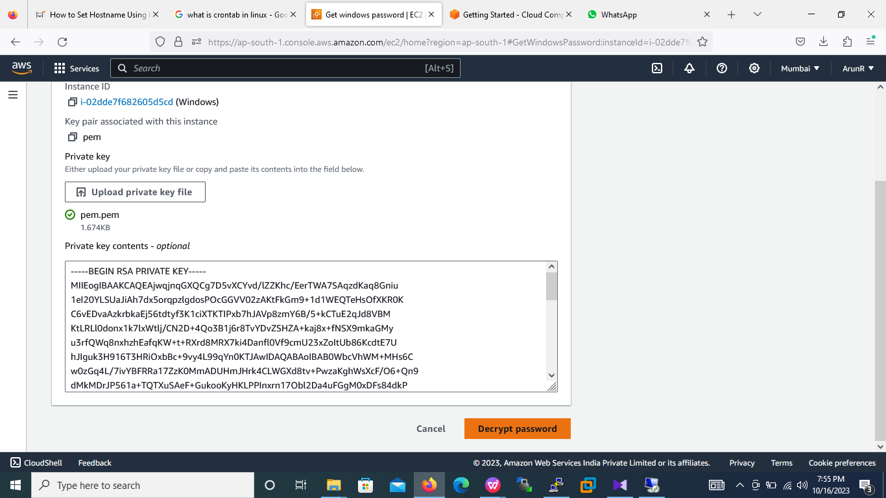

1. After decryption the password, copy the user name and password and paste in RDC credentials(Refer screesnhot12)

Screesnhot12

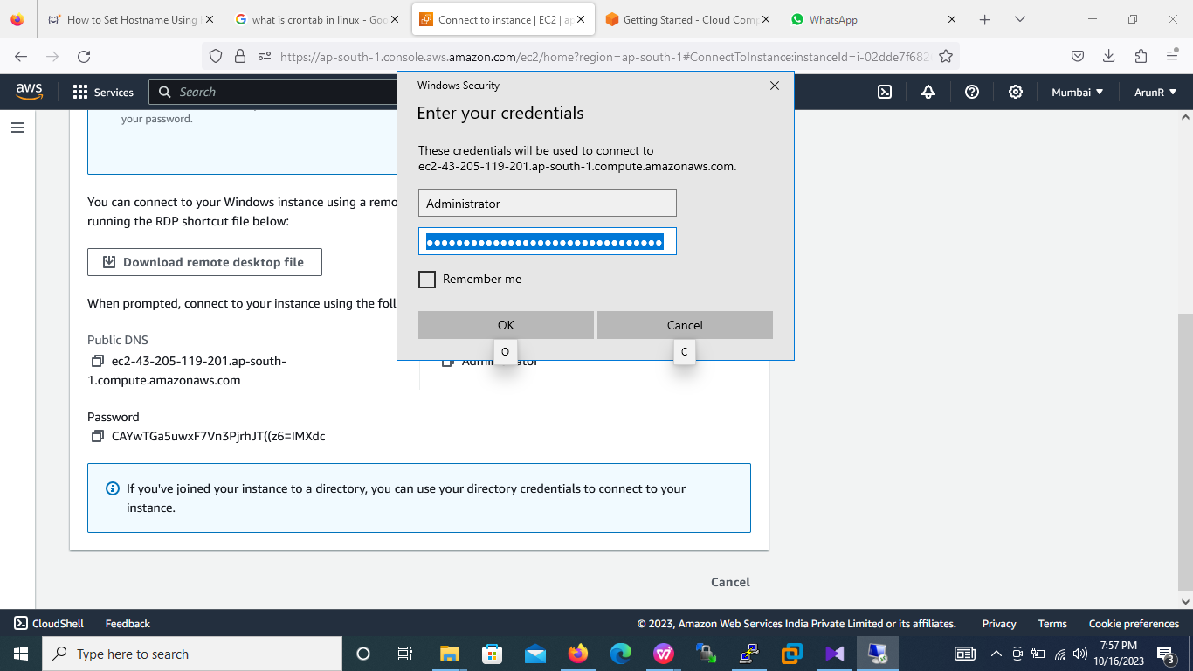

1. Proceed with RDC credentials , then it will open EC2 windows server(Refer screenshot13)

Screenshot13



